Web Development Website Project

**WEBD-1000**

*Website Project*

**Synopsis**

Using HTML5, CSS3, and JavaScript create a website for a hypothetical client, and upload it to the World Wide Web. The content and design of the website is up to you.

*Lorem Ipsum (or any other “ipsum”) is not allowed for your project.

**The “client” could be yourself. Consider making this project a portfolio for yourself that you could include on resumes.

If you have another idea but aren’t sure if it’s appropriate for this project, run the idea by your instructor. You have a lot of latitude!

Pages

Your website must contain at least three HTML5 Validated pages (**any page not validated will result in a mark of zero for the entire assignment**☹ ).

A generic example of your pages could be:

Home page

The home page is a welcome page for the user. It should give a brief description of the company, with some updates on recent activity with the company (i.e. a sale or promotion).

There must be at least two headings of different sizes used on the home page. There must also be at least one image included on the page.

*The home page should **always** be named index.html. When a domain name is typed in a browser (i.e. [www.thinkgeek.com](https://www.google.com/url?q=http://www.thinkgeek.com&sa=D&ust=1554316956100000)), the index page is usually considered the home page by the web server, and is the one that is returned to the browser.

Products/**S**ervices page

A products or services page should describe what goods the company sells or what services it provides.

At least two goods or services must be included. Images and appropriate headings should be included for each good/service, along with a detailed description.

If choosing a portfolio site for yourself, consider listing skills you have.

Contact page

The contact page will include a form the user can fill out to send feedback to or ask questions of the company.

The form should contain at least:

* A name field
* A phone number field
* An email field
* A comments area
* Submit and Reset buttons
* Functional labels for each input

*Use HTML5 input elements where appropriate

Inline validation is required of the contact page. Use an external JavaScript file to ensure the user has entered data in the name field, a ten digit number in the phone number field, and a valid email address (use Regular Expressions).

When an error is encountered, a previously hidden error message should display, focus should be set to the field in error, and the text highlighted.

Style the form so that when the user has focus on a field, its background colour and font colour are changed. All validation should take place once the user has clicked on the submit button.

You can set the form's action attribute to the site’s home page. This won’t send the form data anywhere, but at the least it can simulate the form submission process.

Design

The website will have a common header and navigation area for every page. A footer area should be shown at the bottom of every page, and have a similar look on every page.

Use media queries to ensure that your site is responsive in any resolution.

Header area

The header area is your design choice completely. The only requirement is that it looks exactly the same on each page.

Navigation

The navigation can be horizontal or vertical. It must contain links to every page in your site.

Like the header area, the navigation must be in the same location on every page.

Similar to your previous assignments, the navigation should have “rollover” effects. Meaning when the user is either hovering with the mouse, or has focus on that navigation item, highlighting must be present.

Content

The content area should appear with exactly the same width on each page. Of course, the height is variable on each page.

All other styles for the content are up to you.

Footer

A footer should be included that includes the links the navigation area has, but much more subtle.

If you researched other websites, you would notice that most footer links are using smaller text than anywhere else on the page. This is a common practice in web design, and should be considered here.

Styles

Include all styling within an external CSS page(s).

For the header, navigation, content and footer areas, ID’s should be used, not classes.

Upload to the WWW

The final step of your project is to upload your site to the WWW. There are a few hosting services that offer free hosting of websites. Note that in exchange for hosting your website, they may insert ads into your pages.

Find a free hosting service that allows you to use FTP to transfer your files. [000WebHost](https://www.google.com/url?q=https://www.000webhost.com/&sa=D&ust=1554316956104000) seems to be a popular choice.

**Uploading your files via FTP**

After you have registered, you will notice a control panel area. In here, you can actually use a file manager to upload your files. However, this can be cumbersome.

In Web publishing, the most common practice for uploading files is [FTP (File Transfer Protocol).](https://www.google.com/url?q=http://en.wikipedia.org/wiki/Ftp&sa=D&ust=1554316956105000)

The first thing you’ll need is an FTP client. There are quite a few free options. The one we’ll use for this example is a Firefox plugin called [FireFTP](https://www.google.com/url?q=http://fireftp.mozdev.org/&sa=D&ust=1554316956106000). Download and install the plugin.

In the dropdown menu, select “Create an account…”. In the account manager window, enter the information required. The host in this example is [ftp.tripod.com](ftp://ftp.tripod.com), and the username and password will be the same as your account.

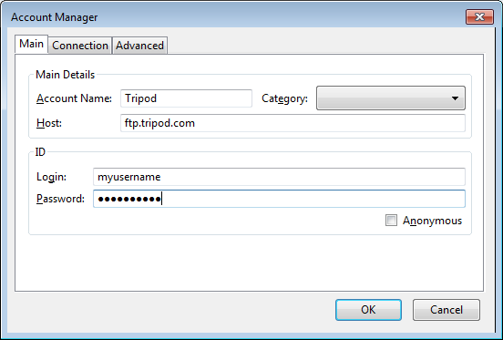

Click on Ok and then Connect.

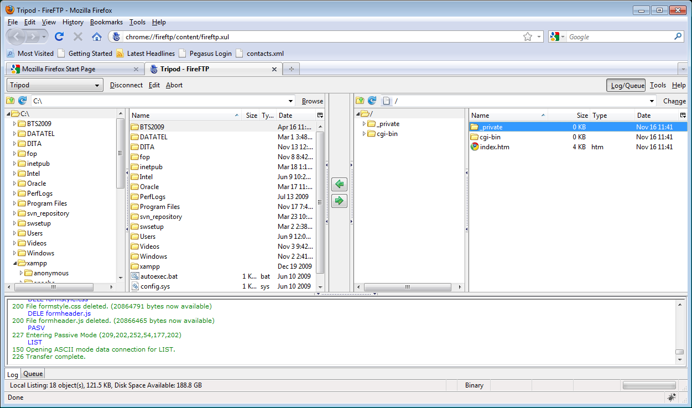

On the left side, you will navigate to your project directory. From here you can select the file(s) that you need to upload to your directory.

Select the files, and click on the green right arrow button (upload) to transfer the files to your domain. And that’s it.

Viewing your site

Navigate to the URL provided to view your website. It may take a couple hours after upload for the [DNS to propagate](https://www.google.com/url?q=https://www.namecheap.com/support/knowledgebase/article.aspx/9622/10/dns-propagation--explained&sa=D&ust=1554316956107000).

*One note about ads, if you’re feeling dangerous, there are ways to remove the ads from your site with a little fancy coding. Feel free to [Bing](https://www.google.com/url?q=https://www.google.ca/?gws_rd%3Dssl%23safe%3Doff%26q%3Dbing&sa=D&ust=1554316956108000) this if you live on the edge.

Due date

Your projects have to be uploaded to your domain *and* Learn by 11:59pm on the last day of classes for the term.  Once you have uploaded your files to your web hosting service *and* to the Learn Dropbox, email the instructor or note in the submission comments of your domain name. (Note that you must zip your files up before submitting to Learn).

Good luck and have some fun!

[Google 드라이브](https://docs.google.com/)에서 게시–[악용사례 신고](https://docs.google.com/abuse?id=1cGL7ayt_DBDiUsh-qjCJKLgocBcahRBoqeHH7J4OY0Y)–5분마다 자동으로 업데이트